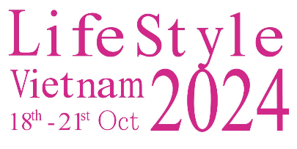

BOOTH APPLICATION FORM
We hereby confirm our participation in Lifestyle Vietnam Fair to be held from October 18-21, 2024, in Ho Chi Minh City according to the following details:

Company name: …………………………………….……………………………………………………………….……………………..…...
Address: …………………………………….……………………………………………………………….………………..……………………..
Contact person: …………………………………….……………………… Title: ………………………….……………..………………
Phone: ………………………….………………………….………….………… Mobile: ………………………….………………………...
Email: ………………………….…………………………….…………….…… Website: ………………………….………………………..
Main products: ………………………….……………………..…….…………………………….………….…………………………………
………………………….…………………………….…………………………….…………………………….…………………………….………….

Required space | Unit price
 | 01 open side | 2 open sides | 3 open sides | 4 open sides
Standard booth of 9m^{2 (*)} | USD1,700 / booth | USD1,800 / booth | USD1,950 / booth | USD2,100 / booth
Number of booth

Raw space (m²) ^{(**)} | USD170/m² | USD180/m² | USD190/m² | USD200/m²
Required area of raw space (m²)
Total space rental (USD)
(*) The standard booth has dimensions of 3m x 3m x 2.5m high, with partitions, carpet, 1 table and 2 chairs, 1 neon bulb, 1 fascia and 1 waste bin. (**) Raw space includes the carpet.
The Organizer offers discounts for exhibiting company that meets the following criteria. Please check the appropriate box:

Criteria | Payment made by 31/3/2024 | Participated in more than 2 editions | Area over 50 m² | Area over 100 m²
Discount rate | 5% | 3% | 3% | 5%

Total space rental after being discounted ……………………………………….………… USD.

Confirmation from the company
(Signature and seal)

Date: …………………………………….…………

